* 7 SEGMENT :-

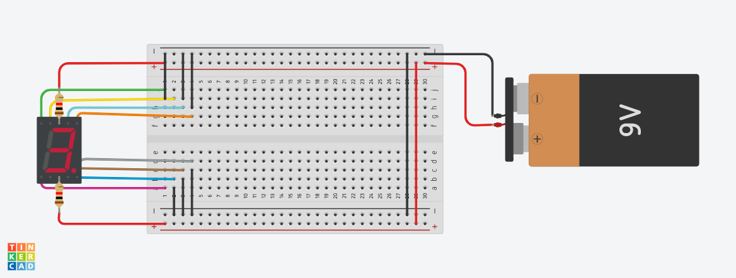

**Circuit diagram**

* **Description :-**

A **seven-segment display** is a form of electronic **display device** for displaying **decimal numerals** that is an alternative to the more complex **dot matrix displays. By this project we try to display 3 in 7 segment displays. We can also show other number in this display.**

* **Application :-** 
  + - * + Digital Clock.
        + Electronic Meter.
        + Basic Calculators.
        + Other Electronic Components that display numerical information.
* **Working Principle:-**

The 7-segment displays are really just seven LEDs lined up in a particular pattern. In this case, the number ‘8’ shape we’re all familiar with. Each of the seven LEDs is called a segment because when illuminated the segment forms part of a numerical digit (both Decimal and Hex) to be displayed. An additional 8th LED is sometimes used for indication of a decimal point. It contains seven LEDs (A, B, C, D, E, F and G) shaped in a figure of 8. Each LED is called a segment. **If a particular LED is forward biased, that LED or segment will light and produces a bar of light**.

* **Circuit Connection :-**

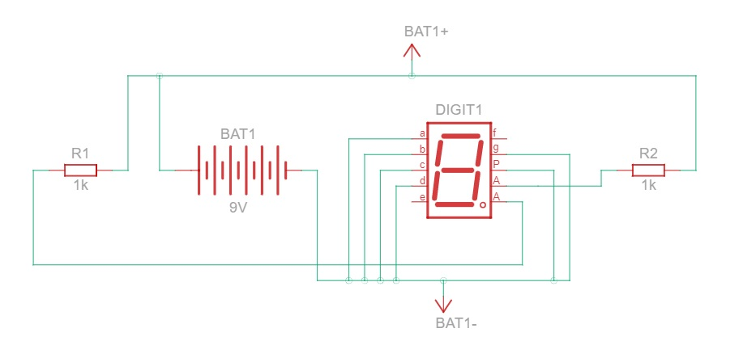

* **Component List :-**

